List of Research Studies Conducted by Climate Change Centre, The University of Agriculture, Peshawar.
S. No | Study Name | Title of Study
1 | Climate Scenarios 2011 – 2040, Districts Haripur, Swabi, Attock and Chakwal Pakistan (2014) | 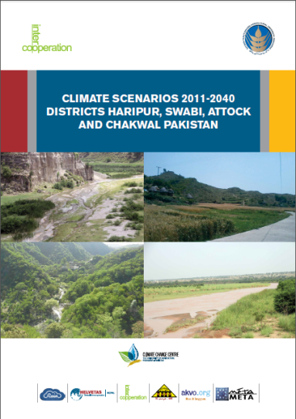
2 | Climate Change and Adaptation – Farmers Experiences from Rainfed Areas of Pakistan | 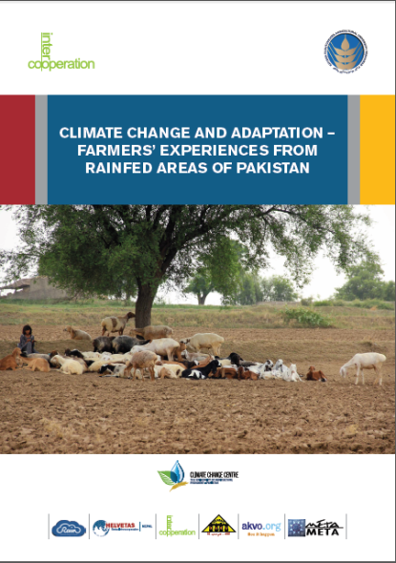
3 | Climate Scenarios 2011 – 2040, Bajaur & Mohmand Agencies (2014) | 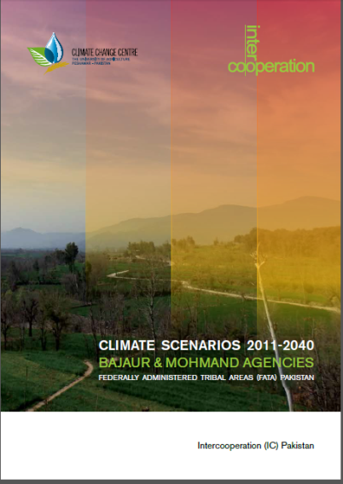
4 | Climate Change in Bajaur and Mohmand Agencies (2014) | 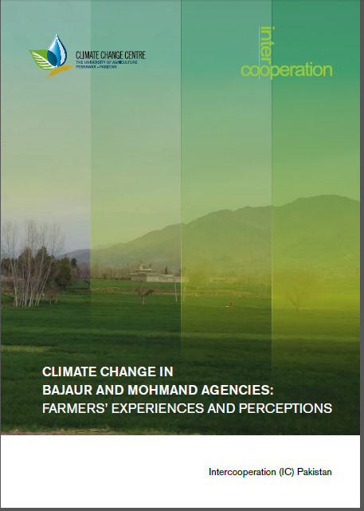
5 | Effect of Sowing time The Yield of Different Maize Variety and Hybrids under Different Agro-Climatic Zones of Khyber Pakhtunkhwa – Pakistan (2015) | 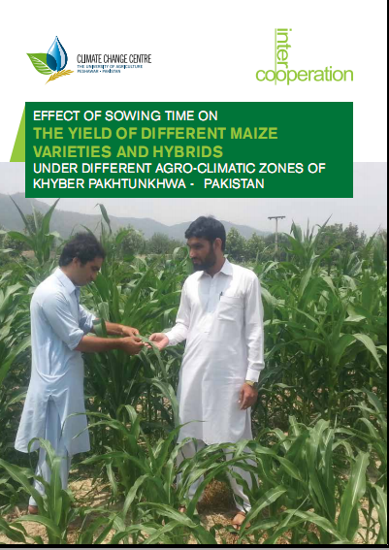
6 | Response Of Wheat Varieties To Sowing Interval As Rainfed / Unirrigated Crop In Khyber Pakhtunkhwa (2014 - 2016) | 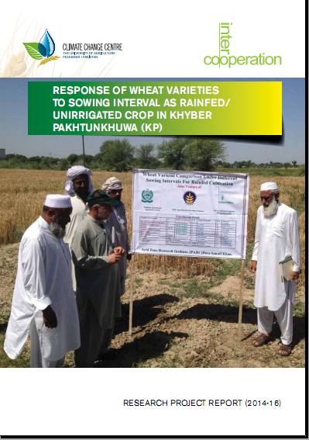
7 | Climate Change Adaptation in Wheat (2016) | 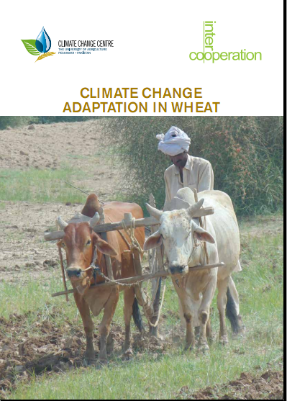
8 | The Effects of Climate Change on Rainfall Patterns and Exiting Rainwater Management in Khyber Pakhtunkhwa (2017) | 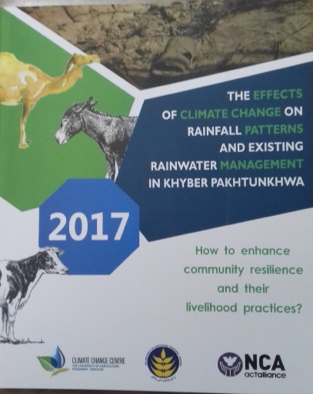
9 | Impact of Climate Change On Older Men And Women, In District Nowshera, Khyber Pakhtunkhwa – Pakistan (2017) | 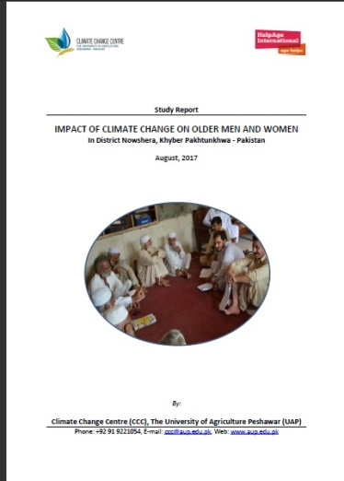
10 | Climate Scenarios 2011-2040 of the ten Districts of Khyber Pakhtunkhwa – Pakistan | 